Dear Friends and Supporters of Nikola Tesla

RE: Nikola Tesla Boulevard – “Let’s Put Tesla on the Map”

Nikola Tesla is one of the greatest inventors of all time. Yet the average citizen outside of Serbia, has barely heard about him. This is all about to change in Canada, thanks to the efforts of the recently formed Nikola Tesla Educational (NTEC), a Registered Charity from Hamilton On.

On October 14, 2016 by a unanimous decision, the Hamilton City Council approved NTEC’s request to rename a portion of Burlington Street to Nikola Tesla Boulevard. Council noted that this was a very unique presentation from the NTEC, as the request came with the offer to pay for the cost of changing the signs. Council acknowledge that this will benefit the city.

https://youtu.be/-oa3bzmXwIA

Nikola Tesla’s technology helped to define Hamilton as the Electric City in 1898. Hamilton was the first major city in Canada to be electrified by AC Electricity. The arrival of electricity in 1898 sparked Hamilton’s greatest boom ever. Major industries made Hamilton their home, as did thousands of new immigrants, who came to work in the many new companies. The Serbians were among them. Hamilton is home to one of the oldest Serbian Churches in Canada formed in 1913.

The Nikola Tesla Boulevard, will replace on portion Burlington Street. This will end the confusion, as currently there are two segments of Burlington Street, the upper portion will be renamed. The important element, however is the section being renamed has a direct access to the Queen Elizabeth Way (QEW) connecting Toronto to Niagara Falls and the USA. This is one of the busiest highways in Canada, with 250,000 travelers daily. The exit is the first exit for the City of Hamilton travelling toward Niagara Falls. The exit Niagara bound has 4 major overhead signs and 3 smaller area attraction sign and Toronto bound exit is identified by 3 major overhead sign. Along the roadway to be renamed there are a further 8 signs that need to be replaced. Of the signs being replace 17 will have the name Nikola Tesla Boulevard. Please see the attached QEW layout to that identifies the 10 QEW signs and their location.

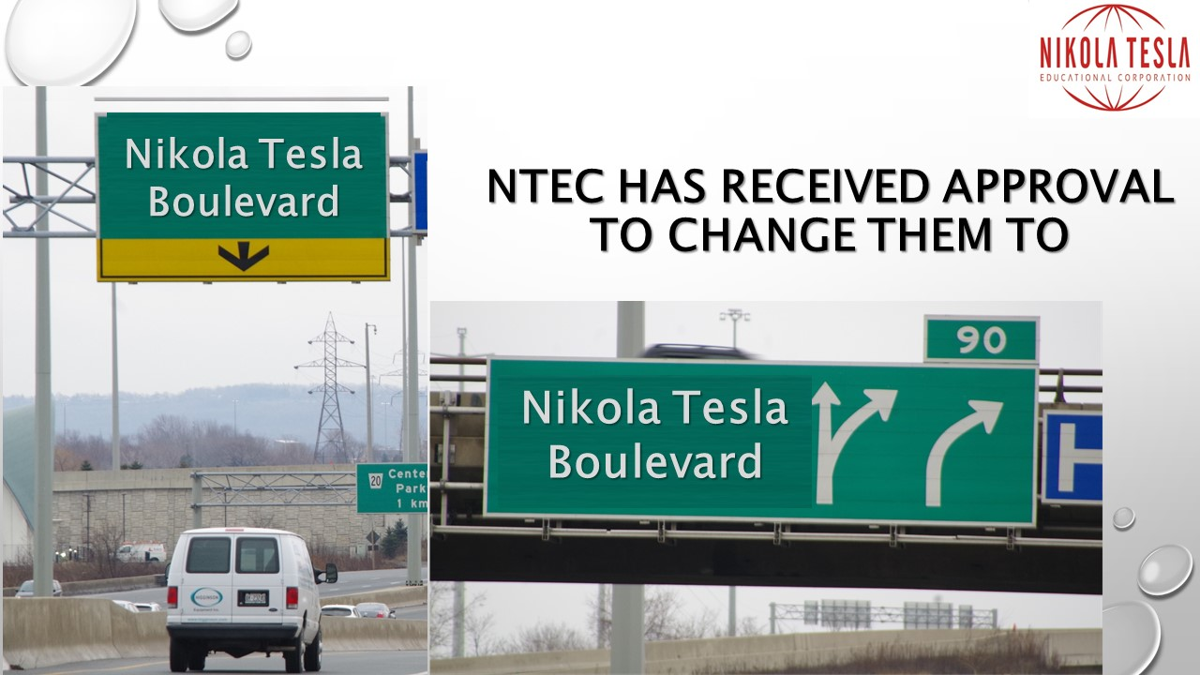

Plans are in progress for the Grand Ceremonies tentatively set for July 10, 2016, Tesla’s 160th Birthday, at which time NTEC will be hosting the ribbon cutting accompanied by sponsors and supporters, along with political dignitaries. NTEC is working to encourage the Prime Minster of Canada to come to Hamilton to take part in the celebration and to raise awareness to the fact that Hamilton has made the decision to embrace new technology that will lead to the “Next Industrial Revolution.” A local paper wrote “Hamilton is becoming Nikola Tesla’s home away from home.”

In addition to Nikola Tesla Boulevard, NTEC mission is to educate and inspire, in particular the youth, through advocating for the inclusion of Nikola Tesla in the general school curriculum and by providing awards and scholarship for student. Michael Wolfe is the first recipient of the NTEC Nikola Tesla Innovation award.

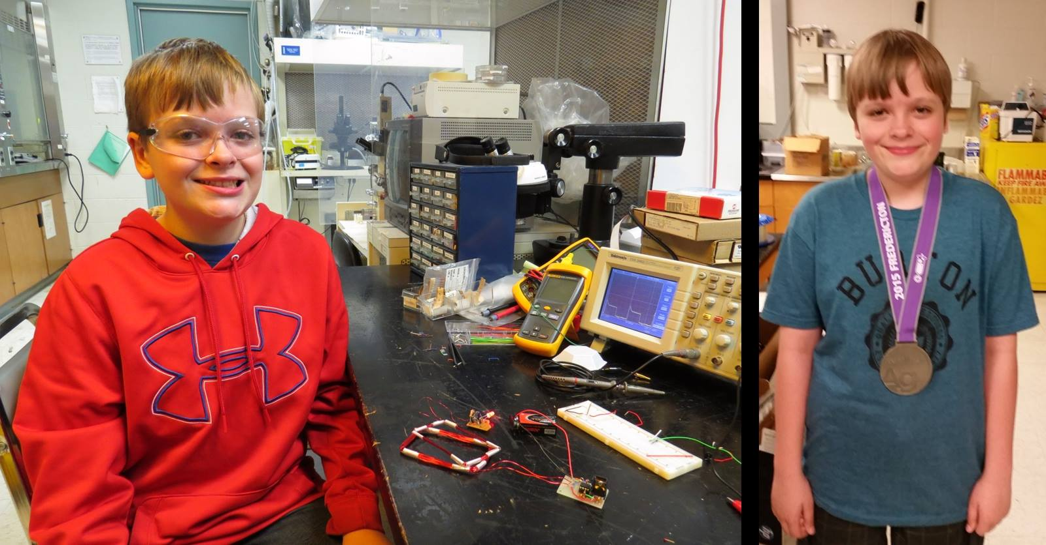
http://engphys.mcmaster.ca/inspiring-grade-8-student/

The pressure is on to get the road name change so that Nikola Tesla becomes a household name in Hamilton. This will set the stage for NTEC to launch a vigorous campaign to name a new High School after Nikola Tesla. Plans are also in discussion for a new exhibit that will feature a statue of Nikola Tesla in Hamilton.

NTEC has set a very ambitious task for the fundraising. The goal is to raise approx. $150,000 by April 2, 2016. That is just 8 week.

NTEC plans to finalize the campaign on April 2, 2016 with a Fundraising Gala at the Winona Vine Estates. Tickets are now on sale, he price $50.00 per person and includes your dinner and entertainment for the evening, plus a $25.00 Charitable Donation receipt.

NTEC is a registered Charity for Canadian Tax Purposes, with the benefit for donors of both getting tax deduction and knowing that there donations are benefiting the City Of Hamilton and more specifically will Put Tesla on the Map, in a major way, unlike no other road in the world. Donation can be made over the internet using PayPal or your credit card. Alternatively instructions are available on NTEC website for alternative avenues for Donation. Please visit www.teslaeducational.ca to make a donation. It should be noted that donors are acknowledged on the on NTEC website and will be featured at the Fundraising Gala. Donors at the Diamond level will be asked to participate in the ribbon cutting ceremonies.

Please give generously, in the name of Nikola Tesla, a man who has given so much and spreading the knowledge of him will inspire generations to come. Let’s Put Tesla on the Map for the whole world to see.

https://www.teslaeducational.ca/donations/

Yours Truly

Veroslav Djurdjevic

Veroslav Djurdjevic, B, CPA, CMA
President Nikola Tesla Educational, a registered Canadian Charity
e-mail: president@teslaeducational.ca
www.teslaeducational.ca
www.facebook.com\teslaeducational\
twitter.com/NTEC_Hamilton
905-541-3469

